# Table of Contents

**Table of Contents** **1**

**Views** **2**

**Super User** **2**

Pages 2

Permission 2

**Admin** **2**

Pages 2

Permissions 2

**Manager** **3**

Pages 3

Permissions 3

**Employee** **3**

Pages 3

Permissions 3

**Pages** **4**

Account creation 4

Dashboard 4

Admin Dashboard 4

Manager Dashboard 5

Employee Dashboard 5

Account Management 5

Employee/Team Page 5

Inventory 5

Login page 6

Password recovery page 6

Job Details 6

Cost analysis 6

**Gamification Concepts** **6**

Score 6

Challenges 6

Level 7

Badges? 7

Flow Diagram 7

**Signatures** **7**

# Views

## Super User

Account used by sargon partners to create and manage admin accounts.

### Pages

* Create account
* List of all admins

### Permission

* Create, delete & view Admin

## Admin

Admin can view all company data. Manage all accounts for a given company.

### Pages

* Admin dashboard
* Account Management
* Employee/Manager Page
* Inventory

### Permissions

* Create/edit/delete accounts
* View any account
* Create/edit/delete team
  + Add employee to team
* Employee/Manager Page
  + View Manager Dashboard
  + View Employee Dashboard
* Change Item Weights
* Add/edit/delete Item (?)
* View employee and team leaderboards
* Link team to a manager.
* View employee job detail.

## Manager

Manager can view their teams and employees that are under them.

### Pages

* Manager Dashboard
* Team view

### Permissions

* View employee and team leaderboards
* View employee job detail.
* Edit team members

## Employee

Can view personal and team information.

### Pages

* User Dashboard
* Job Detail

### Permissions

* View personal and team leaderboards
* View job details.

# Pages

## Account creation

* Select either manager or employee account
* Email (required)
  + Email will be unique and if duplicate it was it will send a popup to the admin and inform them that the email has been used before.
* Username (required)
  + Username will be a unique and if duplicate it will send a popup to the admin and inform them that the username is not unique.
* Password
  + If admin does not fill this field out it will send a temporary password to the required email.
* Company ID
  + Visible but disabled
* First Name
  + If not filled the account will fill it out when first logged in.
* Last Name
  + If not filled the account will fill it out when first logged in.
* Job Title
* Picture
* Address
* Phone number
* Start of Employment
* More Information (?)

## Dashboard

### Admin Dashboard

* Leaderboards
  + Select Time elapsed (last week, month, 3month, 6months, Year, All time)
  + Employee view/ team view
    - Position changed
    - Scores
    - Names
    - Number of Badges
    - Items lost (?)
* Progress of company
  + Weekly Report
    - Badges given
    - Challenges completed
    - Tools Lost
    - Summary Cost analysis *****MAKE A PAGE OF THIS******

### Manager Dashboard

* Leaderboard*
* Progress of team(s)

### Employee Dashboard

* Leaderboard*
* Progress of Individual/Team

## Account Management

* Add/Edit/Delete Account
  + Manager
  + Employee
* Add/Edit/Delete Team
* Viewed as Roster Format

## Employee/Team Page

* View Employee/Team Stats

## Inventory

* Tool List
  + Name
  + Price
  + ID- rfid#
  + Weight
    - Select Weight
  + Cost

## Login page

* Username Field
  + Email
* Password Field
* link to password recovery page

## Password recovery page

* Email Field

## Job Details

* Individual job statistics
  + Items Lost
  + Tool Count
  + Date

## Cost analysis

# Gamification Concepts

## Score

* Score value calculated off of tool data and weights
* Time Dependent
  + Calculated on login from current date to Time frame selected
* Number between 0-1000
* Score is given for each employee and team

## Challenges

* On completion rewards badges and/or exp
* Score (time) based challenges
  + Score > 900 for a month (example)
* Team challenges
  + Based for aggregated scores
* Length of employment

## Level

* Based on Exp received from challenges
* Lvl 1-10 exponential grow, lvl 11+ same exp to next level, no lvl cap
* Reward for levels determined for admin

## Badges?

* Received on challenge complete

## Flow Diagram

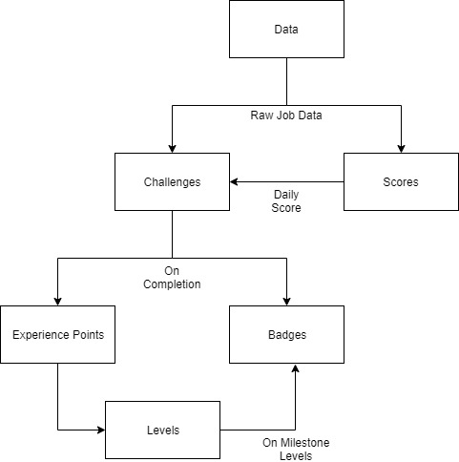

# Signatures

|  |  |
| --- | --- |
| Client |  |
| Team Lead |  |